E-mas Inventory Control System

Features Make the things work

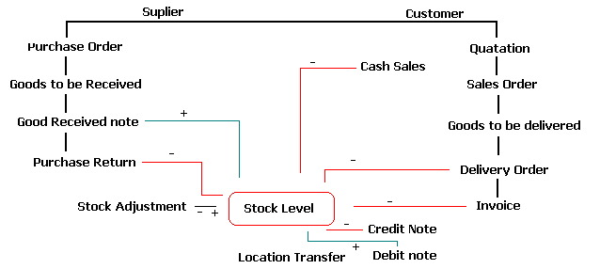Business Activities

Inventory Control system is a Financials application that provides sales and Cost of goods sold throughout Business Transaction.

Security
As a system developer, we understand that your information is very available and we build advance security to prevent data easily loss. Simply to operate but security you need.

Assign Job & Responsibilities
The system provides menu assignment according to once jobs and responsibilities. E.g. the warehouse personnel is allowed to issue the delivery order and inquiry the stock on hand, user can assign and the system will omit the command or function in the menu or even fields. The user log in the correct name and password, the system will automatic execute his menu which is different from the other user.

Transaction Tracking
Individual user has I.D. and Password respectively. The system is automatic tracking whom and when issue the bill. The system also provides the information on whom, when, how and what have been deleted or changed.

Minimum Inventory

Level Control
In order to avoid the Inventory is running out of stock, the Inventory Control System is providing warning if the item is below your minimum stock level. In this case, you can plan and schedule each sales and purchase transaction for minimum inventory levels without compromising customer service.

Multi Currency Trading
E-mas Inventory Control System offers flexible and effective Multiple-Currency capabilities for companies conducting international business. Reports can be printed either in customer’s currency or your base currency. Inventory Costing is automatic calculated according to currency fluctuated.

Partial Delivery
Outstanding Sales Order items or Purchase order items, is showed as user issue Delivery Order or Stock Received. (Goods To Be Delivered). User knows the balance outstanding item with quantity needs to delivery or receive.

Available Stock
Available stock quantity is provided when doing transaction.
Provide immediate information to customer when and quantity sufficient for delivery.

Unit of Measurement
The ability to use option units of measurement for controlling inventory. E.g. you may buy items in box, sell them in pieces. There is a table for user to key in seven different unit convention factors.

Credit Limit Control
Over credit limit message will prompt out as the customer is over the credit limit set. The information prompt out is outstanding balance, credit amount and over amount. Supervisor password needs to enter to approve the transaction.

Selling Price Control
User can set the net price or cannot sell below the cost price. The message is prompt out if the item is sell below the net price or cost price. Supervisor password is needed for approve the transaction.

Secret Code for Cost
To avoid cost price is link out; secret code for cost is provided and preset by the user.
The Reports with cost printed will be printed in secret code set by user.

Selling Price / Purchase Price
Base on customer and base on different date different price. Different quantity is different price. Different customer is different price.
Pictures of Item
Photographs and drawings that show items on screen can be used for identify.

Reorder Advise
You can set up an efficient procedure for reordering by specifying, on item profile, the minimum and maximum inventory levels and a reorder quantity. This can provide user items need to order.

User Define Fields
User can add in define fields and write the formula return back the formula.

Location Transfer or Consignment
The System provides location transfer & consignment features to let the user easy to find the goods and location profits. User can track quantity of goods in the customer place (consignment).

Kit Item
Assembly the item with unfixed items. Selling the assembly components in set and providing the component’s profit and selling price in components respectively.

Assembly Item
Assembly features can provide user building finish product with automatic calculate the finish product cost.

Swap Parts
After assembly the finish product, upon issuing bill, user can change the components and quantity. The components can be omitted.
The Stock Control will be accurate.

Integrated with Accounting System
The E-mas Inventory System is fully integrated with E-mas Accounting System. User can updated the data as they wish.

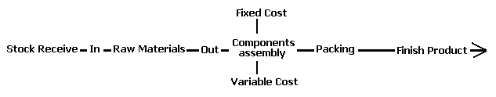

Assembly Activity

Default Reports

- Reports One
- Bills Check List
- Outstanding Delivery Order
- Delivery Listing
- Group Sales
- Group Sales - Summary
- Category Sales
- Category Sales - Summary
- Location Code Listing
- Opening Quantity Listing
- Opening Quantity Listing - By Group
- Physical Worksheet - By Group
- Physical Worksheet - by Location
- Stock Card
- Month To Date Status
- Debtors Listing
- Creditors Listing
- Group Code Listing
- Category Listing
- Item Code Listing
- Selling Price - Print By Item No
- Selling Price - Print By Customer No
- Purchase Price - Print By Item No
- Purchase Price - Print By Customer No

- Reports Two
- Sales Analysis by Agent by Customer
- Sales Analysis by Agent
- Sales Analysis by Agent by Area Print Summary
- Sales Analysis by Area by Customer
- Sales Analysis by Area by Product
- Sales Analysis by Area by Group
- Sales Analysis by Area by Summary
- Sales Analysis by Bill
- Sales Analysis by Customer - Summary
- Sales Analysis by Product
- Yearly Sales by Area
- Yearly Sales by Agent
- Yearly Sales by Agent by Customer
- Yearly Sales by Customer
- Yearly Sales by Group
- Yearly Sales by Product
- Yearly Sales by Product by Customer
- Report Four
- Purchase Return Audit Trail by Ref
- Purchase Return Audit Trail by Vendor
- Purchase Order Audit Trail
- Sales Order Audit Trail
- Packing List by Item
- Packing List by Group by UDF1+Item No
- Gross Profit by Customer
- Gross Profit by Agent
- Gross Profit by Area
- Gross Profit by Product
- Gross Profit by Group
- Yearly Purchase by Vendor
- Yearly Purchase by Group
- Yearly Purchase by Product
- Yearly Issue by Product
- Quantity On Hand by Location
- Quantity On Hand by Location - Print by Group
- Location Sales
- Location Profit
- Month To Date Item Status - Print By Group
- Transaction Summary
- Project Report
- Packing List D/O-Group by Item No
- Packing List D/O-Group by UDF1+Item No
- Packing List Sales Order - Group By Item No
- Packing List Sales Order - Group By UDF1+Item No
- Quotation Based On Item No
- Quotation Based On Customer No
- Available Stock Balance Report
- More Description Report
- Goods Received Note By Group
- Issue Note by Group
- Month To Date Item Status - Print By Location
- Month To Date Item Status - Print By Group + Category
- Month To Date Item Status - Print By Details
- Item Valuation Report - Print By Location
- Invoice Audit Trial by Date
- Invoice Audit Trial by Item No
- Sales Analysis by Agent by Product - Print Quantity
- Top Sales by Quantity
- Top Sales by Sales Value
- Bottom Sales by Quantity
- Bottom Sales by Sales Value
- Stock Aging

- Report 4.3

- Credit Note Audit Trail
- Debit Note Audit Trail
- Cash Sales Audit Trail
- Adjustment Audit Trail
- Stock Issue Audit Trail
- Stock Received Audit Trail - By Vendor
- Location Transaction Audit Trail
- Purchase Analysis
- Bill Check List - Stock Received
- Bill Check List - Purchase Return
- Item Code Listing - Sort by Item No
- Quotation Based On Agent
- Gross Profit by Category
- Invoice Audit Trail by Ref
- Invoice Audit Trail by Customer
- Stock Received Audit Trail - By Ref
- Delivery Order Audit Trail
- Item Assembly Audit Trail
- Out Of Stock Summary
- Ship To Address
- Item Valuation Report
- Gross Profit by Invoice
- Gross Profit by Cash Sales
- Outstanding Sales Order
- Item In Sales Order
- Sales Order In Delivery Order
- Sales Analysis by Customer - Details
- Sales Analysis by Agent by Product
- Sales Analysis by Agent by Area
- Print Agent Code
- Item Assembly Listing
- Bill Of Material Listing
- Delivery Order Listing
- Reorder Advise
- Purchase Order in Received
- Item In Purchase Order
- Outstanding Purchase Order
- Sales Order In Invoice
- Top Purchase Listing - By Quantity
- Top Purchase Listing - By Value
- Bottom Purchase Listing - By Quantity
- Bottom Purchase Listing - By Value
- Gross Profit by Invoice - Format 2
- Sales Analysis by Bill - Format 2
- Miscellaneous Charges Listing
- Top Purchase Listing - By Quantity (Vendor)
- Top Purchase by Sales Value (By Vendor)
- Bottom Purchases by Quantity (By Vendor)
- Bottom Purchases by Value (By Vendor)

